COVER PAGE

Course code: WSOA3003A

Student number: 2152594

Name: Jodi Chapson

Focus: Communication Design

Assignment: Reflection and Analysis on Assignment 2

Due: 1st of April at 14:00

For this assignment, we were required to build on our previous Unity Project from Assignment 1 – a turn-based combat game. The focus of this prototype was on communication design – and hence the communication of vital information to the player. This is Into the Dark – prototype 2.

Prototype 1 was left at a basic turn-based combat game with no animations or visual/particle effects. In terms of UI: there were individual health bars for enemies and players, that floated above them during the whole game – regardless of whether in or out of combat (see Appendix 1). This was originally so that a player would always know how much health they and/or the enemies had, even if they were not fighting at present. During battle, special buttle HUDs would appear (see Appendix 1) that would display the health and damage stats of the player and enemy, respectively.

In prototype 2, further revision found that simply having the green health bars floating above the characters throughout the game, was not enough. The health bars themselves could only vaguely represent how much health a character had in relation to their max health. They had no means of communicating a concrete number such as 5 or 12. Looking at the health bar alone, the player has no means of gauging exactly how much health they started with, and exactly how much health there was left. On the other hand, a bright green health bar communicated information much faster than say, a roster of closely clustered numbers at the corners of the screen containing the stats for health and damage.

On another note, I felt that having two separate pieces of UI (the health bar and the battle HUDs) that both were intended to communicate the same information (health), forced the player to look in two different places for information that should be more easily and comfortably found in one. For example: The Battle Hud only showed the current health, while the health bar showed only the current health in relation to the max. If a player wanted to get a clear idea of the state of their health, they would have to look at two different UI elements placed in two different areas of the screen.

Hence, in prototype 2, I chose to condense these two UI elements into one new and improved battle HUD. The health bar was removed from its place hovering above the protagonist/enemies and was instead merged with the old battle HUD (see Appendix 2). For the player, the new HUD will stay visible throughout the game so a player can always see their stats, while the enemy HUDs will only appear during battle with their respective stats. In this way, players only need to look in one place for information on their own health and damage, and for the health and damage of enemies.

Several other changes were implemented aside from alterations to the display of the health stat. Firstly: a character sprite for the respective enemy/player was included in the battle HUDs – not only to make the HUD more visually appealing and colourful, but to also help identify which information belonged to which character. However, upon further reflection, I realize that this may pose an issue if there were multiples of the same enemy type in the battle at the same time (like 3 fire elementals). How would one know which information belonged to which enemy? If I implemented battles with multiple enemies in the future, this will be an issue that I will have to tackle.

The representation of the damage stat was changed. To reduce the number of words/letters in the battle HUDs, I added in a special damage symbol. For normal attacks (so that of the player and the normal enemy), they have a sword symbol for damage. Whereas elemental enemies have their own special symbols; fire enemies have a fire symbol next to their damage stat (see Appendix 2). This way, the new battle HUDs will communicate both the amount of damage a character deals, and the TYPE of damage. This was implemented because, in the future, it was intended that there be characters of a variety of elemental attunements on the battlefield. Different elements can lead to different elemental reactions and effects. So always having access to important information like damage types and elemental attunements, will help the player keep better track of the battlefield and their opponents.

I also added a small bouncing arrow that indicates whose turn it is. This way a player can keep track of the game state – especially since there are minimal-to-no animations for the protagonist and enemies at this stage in prototyping. The arrow will bounce back and forth between the player and the enemy during battle to show turns.

I did some minor animations for the player to better communicate their various states and actions i.e., idling, walking, attacking, and flinching. I did not manage to make animations for the enemies, so to help with communicating attacks (the most important part of battles), I added in damage figure particles, to not only communicate that damage was dealt to a certain character, but to also communicate the amount of damage and type of damage (bottom right of Appendix 2).

Finally, I fixed an issue with the health bars where, when they were full, they did not appear entirely full (see Appendix 1) and when health was below 0, health bars still showed a small sliver of green.

In reflection, I am quite happy with my work on the UI and HUD of Into the Dark from prototype 1 to this prototype 2. I felt that now vital information such as health, damage, and certain actions/states of the player-character are properly communicated. However, the current battle HUDs mainly suit 1v1 fights. If I were to expand the game to feature multiple characters in a fight, the current UI, though comparatively more compact that its predecessor, would take up way too much space if each character (in a battle of say 3v3 or 4v4) were to have their own battle HUD. If it comes to it, these may need to be compacted even more to save on screen space.

APPENDIX 1

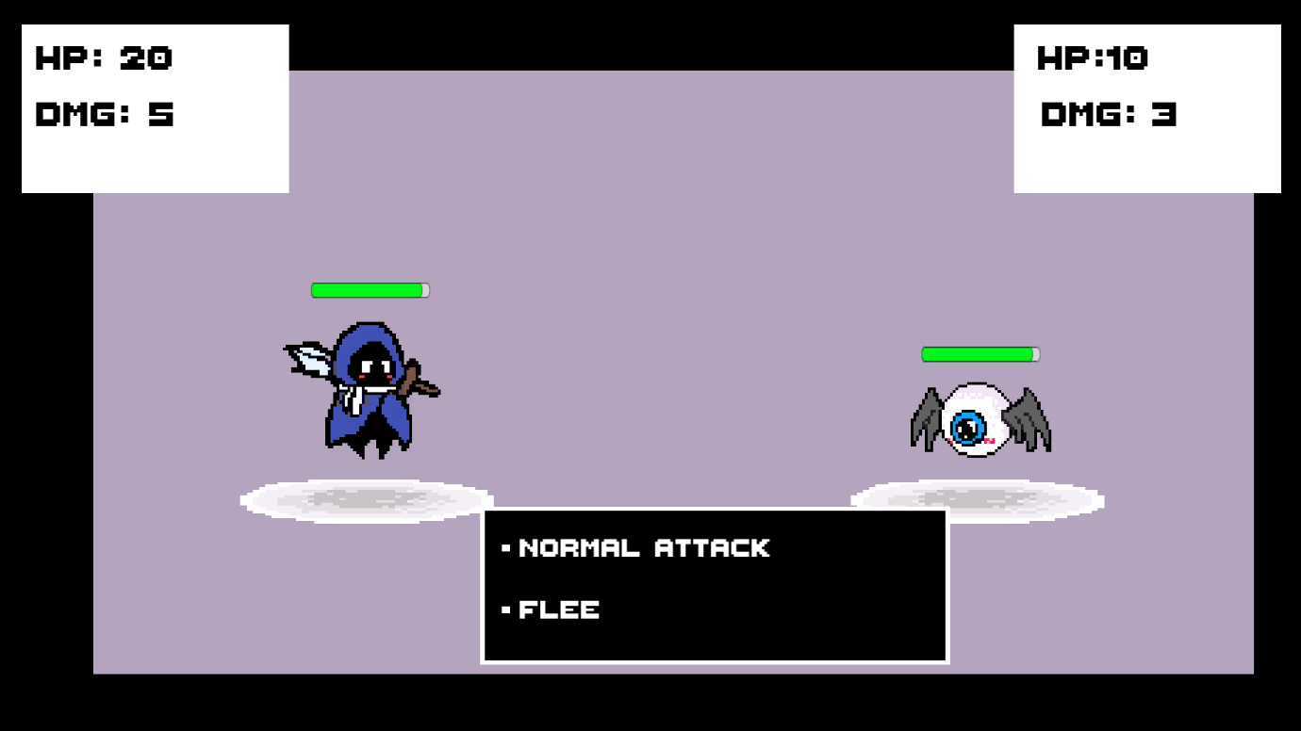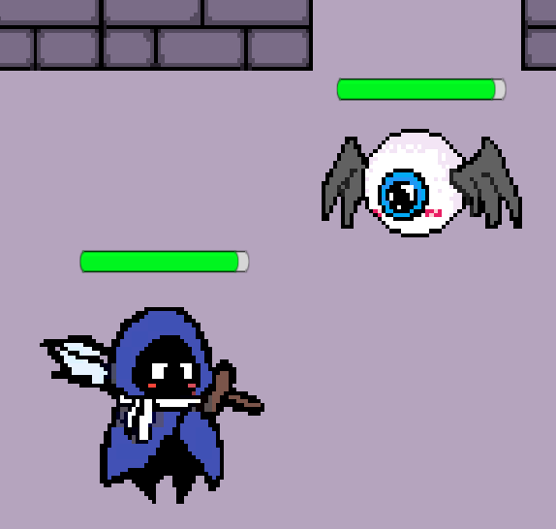

Protype 1 UI: for in-combat (above) and out of combat (below)

APPENDIX 2

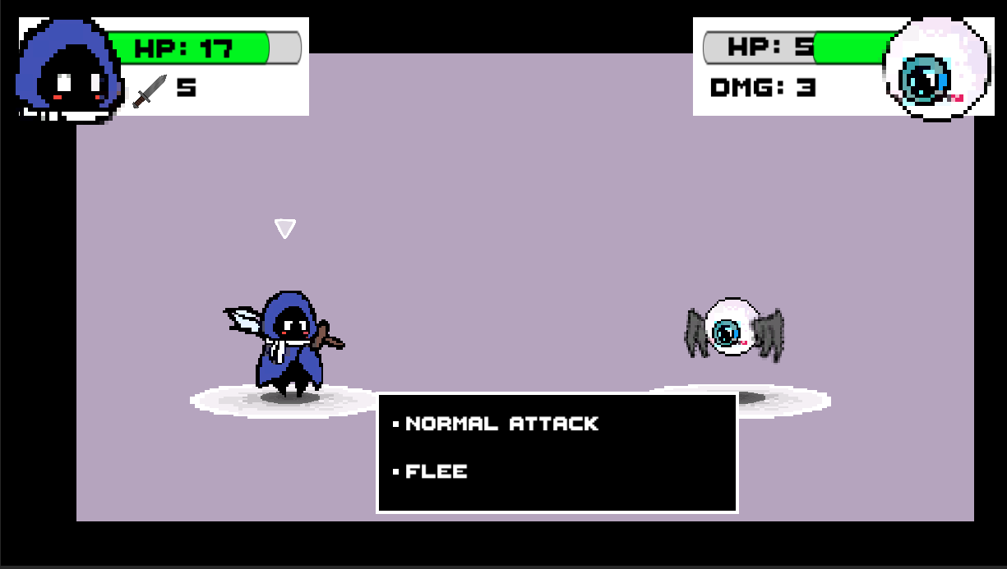

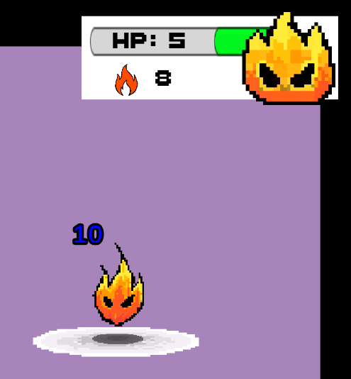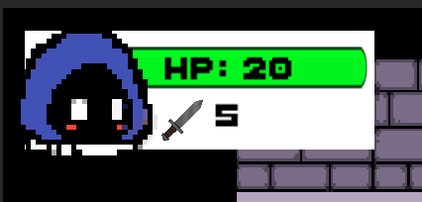

Protype 2 UI: for in-combat featuring the new player/enemy HUDs with turn-indicating arrows. Bottom left: Fixed player HUD on full health. Bottom right: Fire elemental HUD with blue damage indicator.